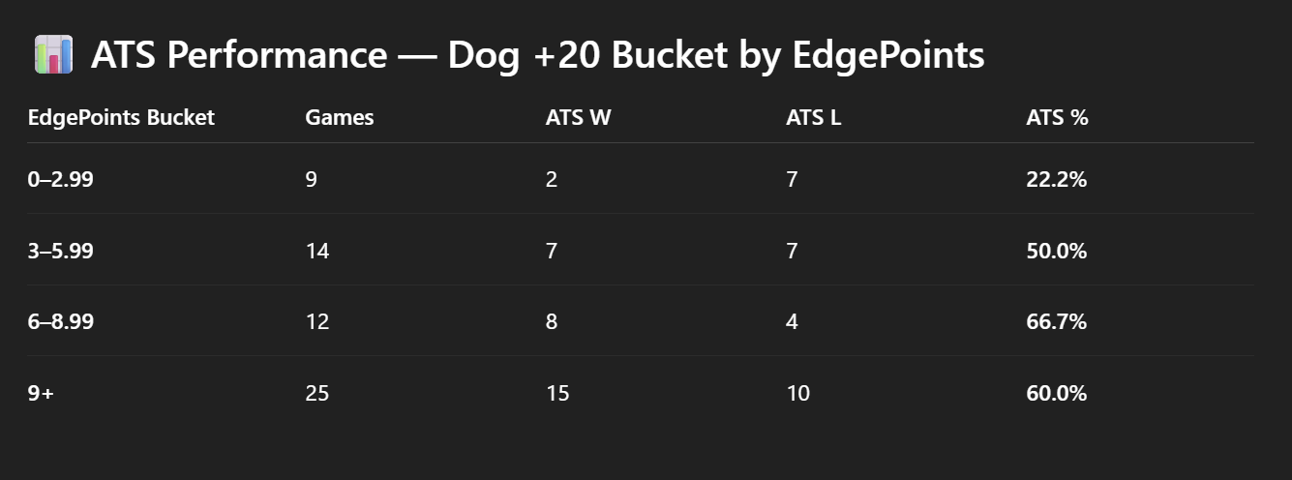

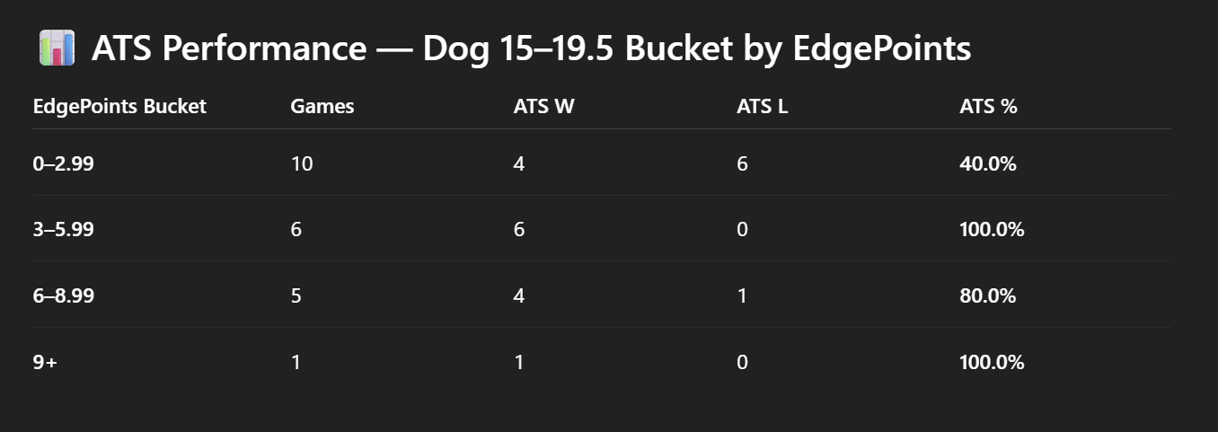

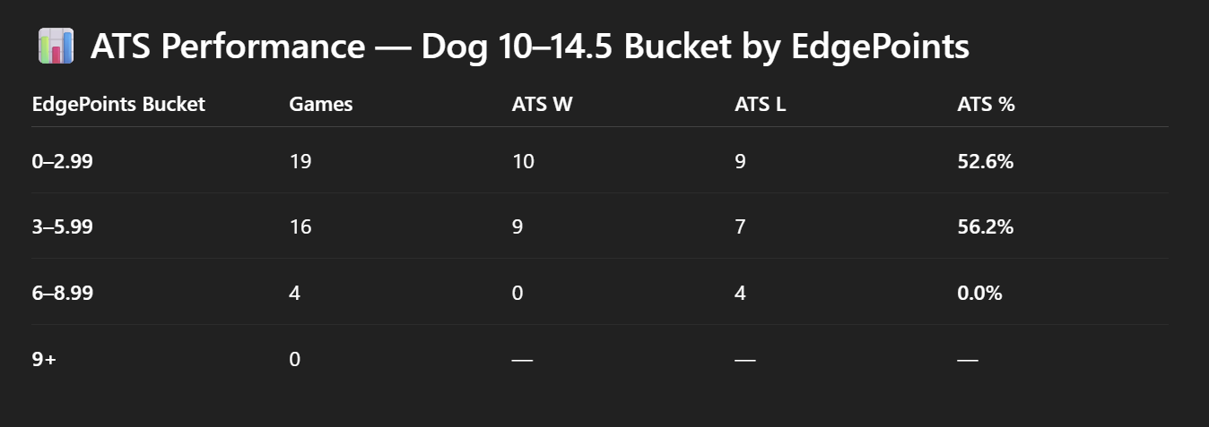

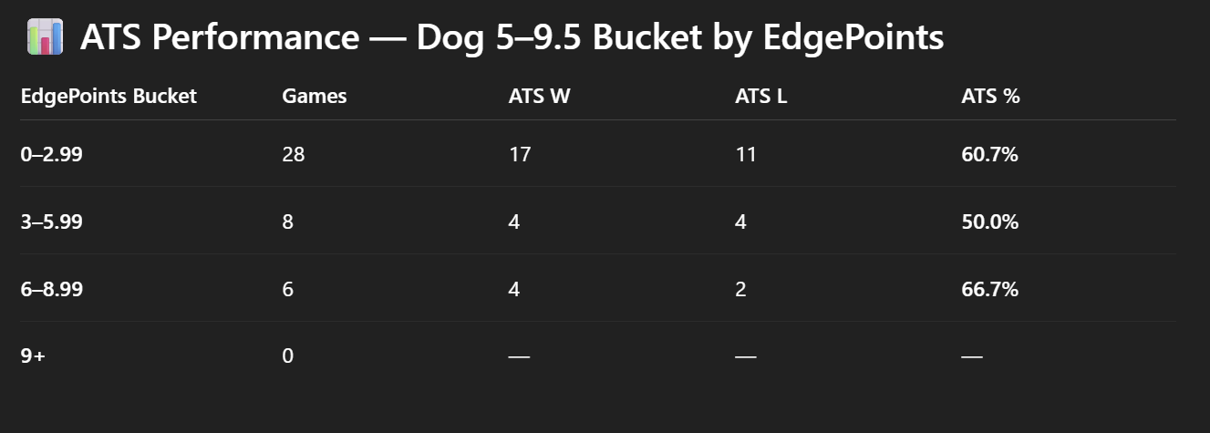

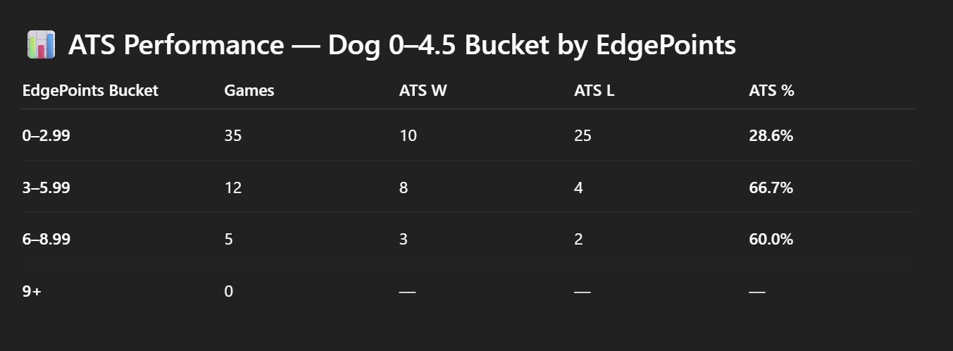

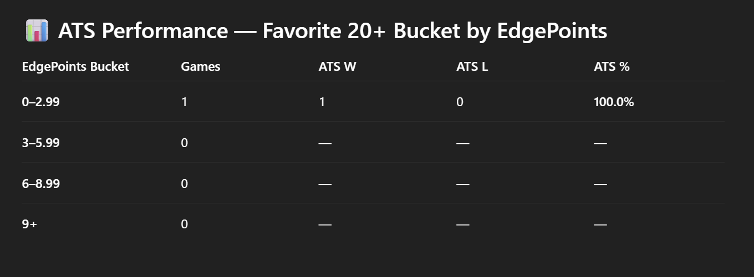

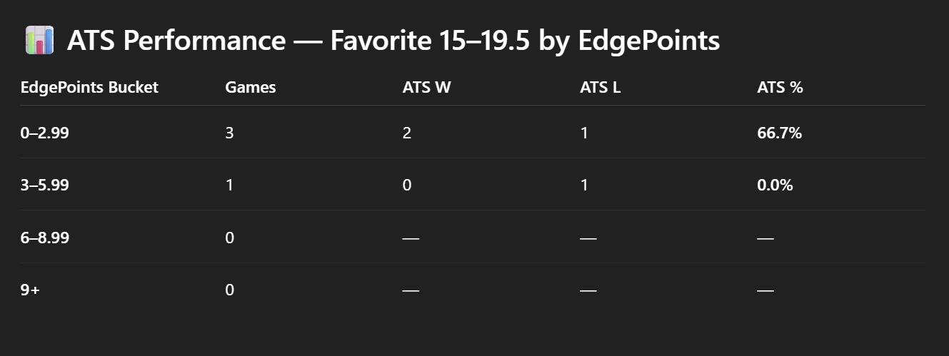

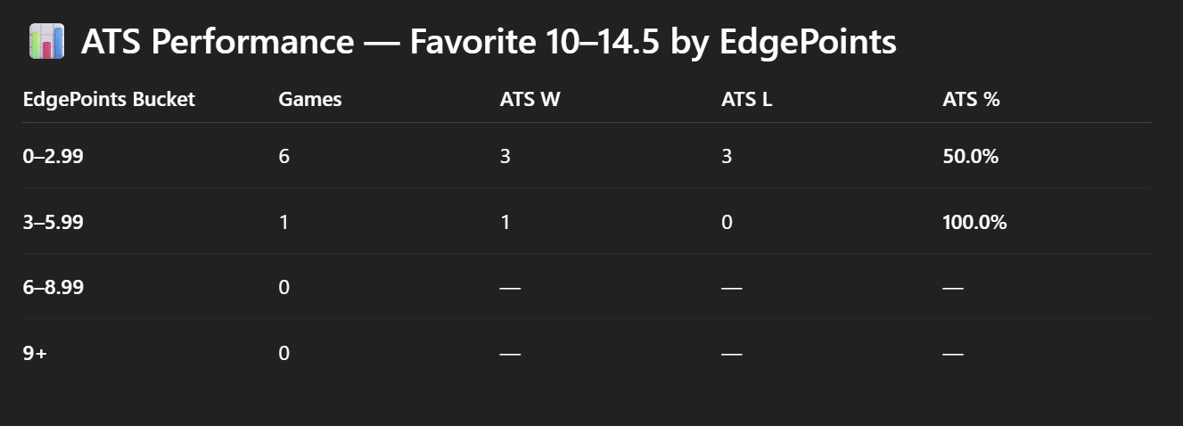

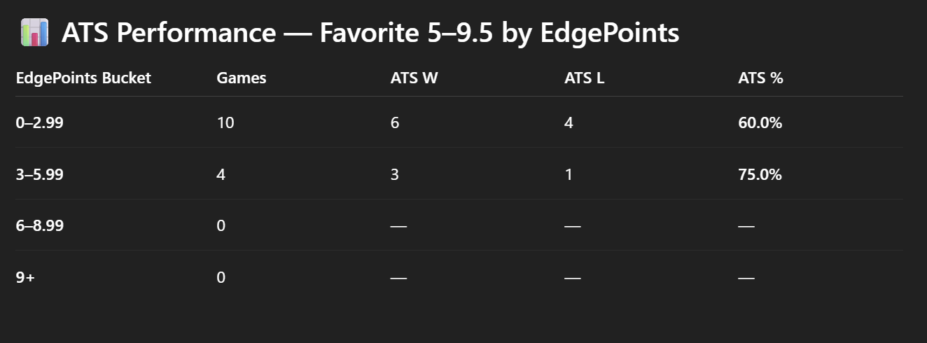

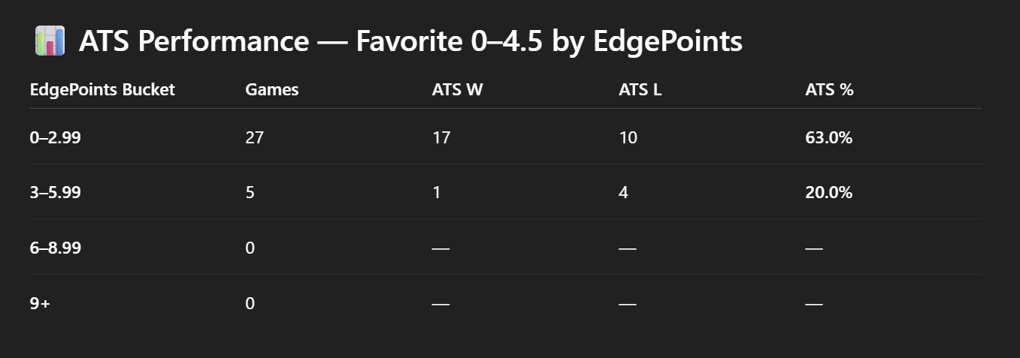

🚀 PHASE 1 — Establish Presence (Day 1–3)
1️⃣ Create your EdgeLab accounts
- Twitter/X
- Bluesky
- Substack
- Discord server (private for now)
We already have:
- Headers
- Profile icons
- Substack masthead
- Brand kit
So setup will be clean and fast.

2️⃣ Upload the brand assets
- Use official EdgeLab logo for profile picture
- Use the Twitter header
- Use the Bluesky header
- Use the Substack masthead
- Use the Discord icon
Consistency = credibility from Day 1.

3️⃣ Write your bios (I can write these for you)
Twitter/Bluesky Bio
EdgeLab — Advanced Betting Intelligence
Data-driven NCAA hoops model | ATS buckets | Daily picks
No vibes. No narratives. Just math.
Substack ⬇️
Substack About
A longer polished version (I can write that too).

🚀 PHASE 2 — Seed Content (Day 3–5)
Before announcing anything, you want 4–6 pieces of content already posted so visitors see value immediately.
Recommended "seed posts":
✔ 1. Introducing EdgeLab (tweet + bluesky post)
A simple graphic with explanation.
✔ 2. Historical bucket performance
“Dogs +15 to +19.5 with EP ≥ 3 are 12–1 ATS this season.”
✔ 3. A sample Daily EdgeCard
You already have the graphics for this.
✔ 4. A Hot Bucket Alert
Tease high-confidence buckets.
✔ 5. Your origin story
Why you built EdgeLab.
✔ 6. Substack pinned post
Your launch article.
I can write all of these for you.

🚀 PHASE 3 — Official Launch (Day 5–7)
This is the moment.
1️⃣ Publish the Substack launch post
Lead with:
- Why EdgeLab exists
- How it’s different
- What the model does
- How ATS buckets work
- What subscribers get
- Free vs paid plan
I’ll write a polished version when you’re ready.
2️⃣ Launch tweet thread
This is your viral moment.
I’ll write a 7–10 tweet thread optimized for exposure, retweets, and signups.
3️⃣ Launch Bluesky post
More long-form and less hypey than Twitter.

🚀 PHASE 4 — Daily Operations (Ongoing)
You’ll have a repeatable daily workflow:
Morning:
- Generate model output
- Apply your ruleset
- Produce the Daily EdgeCard
- Post to:
  - X
  - Bluesky
  - Substack (full slate behind paywall, free picks on top)
Afternoon/Evening:
- Engage comments
- Track results
- Prep next day
Weekly:
- Weekly recap post
- Hot buckets rundown
- Transparency report
- Results dashboard (I can automate this eventually)

🚀 PHASE 5 — Monetization (Once consistent posting begins)
Paid Substack Tier
Unlock early:
- Full daily slate
- Full EP bucket analysis
- Full market/model differences
- Neutral-site edge performance
- “What to bet today” list
Monthly: $9
Yearly: $75

Premium Discord Tier
Open when you reach 200–300 subs:
- Live in-game edges
- Steam movement tracking
- Late-line opportunities
- Group discussion
- Daily AM/PM model updates
Price: $25–50/mo
This is where real recurring revenue begins.

🚀 PHASE 6 — Expand the Ecosystem
Once EdgeLab grows:
- NCAA Football model
- NFL props
- MLB totals
- AMP (EdgeLab All-Models Plan)
- YouTube shorts / TikTok highlights
- Podcast clips
- Automated dashboards
- Website
- Merch (EdgeLab crewnecks would slap)

